Airforce Blue
Alien Green
Apple Green
Arctic White
Ash
Baby Pink
Black
Bottle Green
Bright Green
Bright Orange
Bright Red
Bright Royal
Burgundy
Burnt Orange
Camel
Candyfloss Pink
Charcoal
Chocolate
Classic Red
Convoy Grey
Cornflower Blue
Cranberry
Cream
Desert Sand
Fire Red
Fizzy Lemon
French Navy
Fuchsia
Gold
Green
Grey
Hawaiian Blue
Heather Grey
Hot Chocolate
Hot Pink
Jade
Jet Black
Kelly Green

Kiwi
Lavender
N.B, Colours are very approximate.
Badge looks much better in reality.
Light Oxford
Lilac
Lime
Lipstick Pink
Magenta Magic
Moondust Grey
Moss
Navy
New French Navy
Ocean
Olive
Orange Crush
Oxford Navy
Peppermint
Pink
Pinky Purple
Plum
Purple
Red Hot Chilli
Royal
Sapphire Blue
Sky
Slate Grey
Please check colour availability for each type of garment.
Steel Grey
Storm Grey
Sun Yellow
Sunset Red
Surf Blue
Teal
True Violet
Turquoise Surf
Turquoise
Vanilla Milkshake
Vintage Red
Vivid Blue
White
Winter Emerald
Yellow

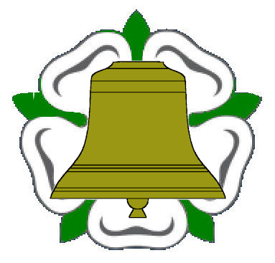
Yorkshire Association

